Reconnaissance – Active and Passive Recon
Document your findings, including screenshots, and answer the questions provided.

SESSION 1 — Passive Recon

1. DNS & Domain Enumeration
Commands to run:
- host zonetransfer.me
- nslookup zonetransfer.me
- dig zonetransfer.me NS
- dig zonetransfer.me MX
Record Findings:
• IP Addresses: _______5.196.105.14___________
• Name Servers: _____nsztm1.digi.ninja, nsztm2.digi.ninja__________
• Mail Servers: ___ASPMX2.GOOGLEMAIL.COM, ALT2.ASPMX.L.GOOGLE.COM, ALT1.ASPMX.L.GOOGLE.COM, ASPMX3.GOOGLEMAIL.COM, ASPMX5.GOOGLEMAIL.COM, ASPMX4.GOOGLEMAIL.COM, ASPMX.L.GOOGLE.COM____
Screenshot:
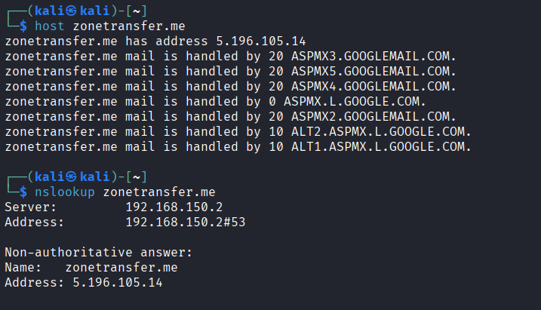
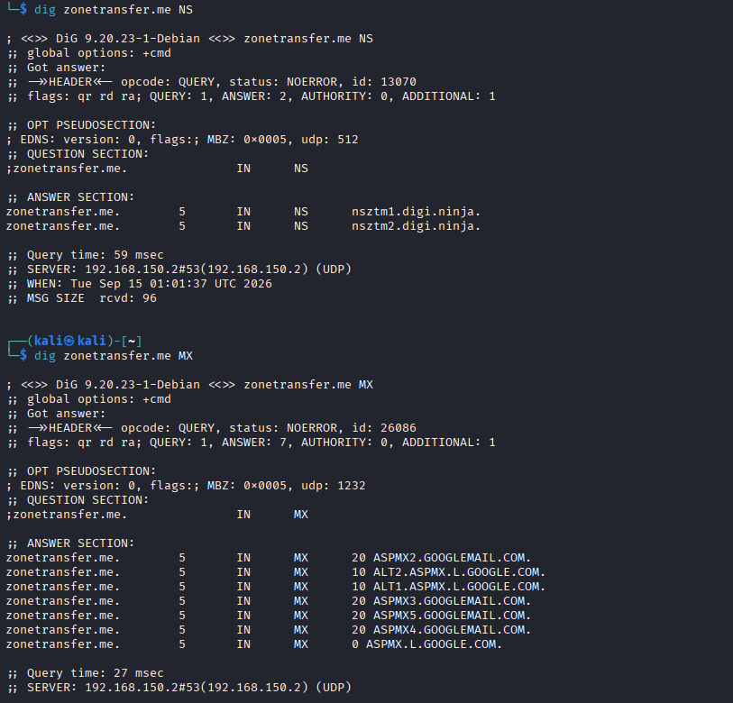

2. WHOIS Lookups
Commands:
- whois zonetransfer.m
Record:
• Registrar: ______Mesh Digital Limited________
• Organization: _____Domains By Proxy, LLC______
• Hosting Provider: ___DigiNinja____
Screenshot:
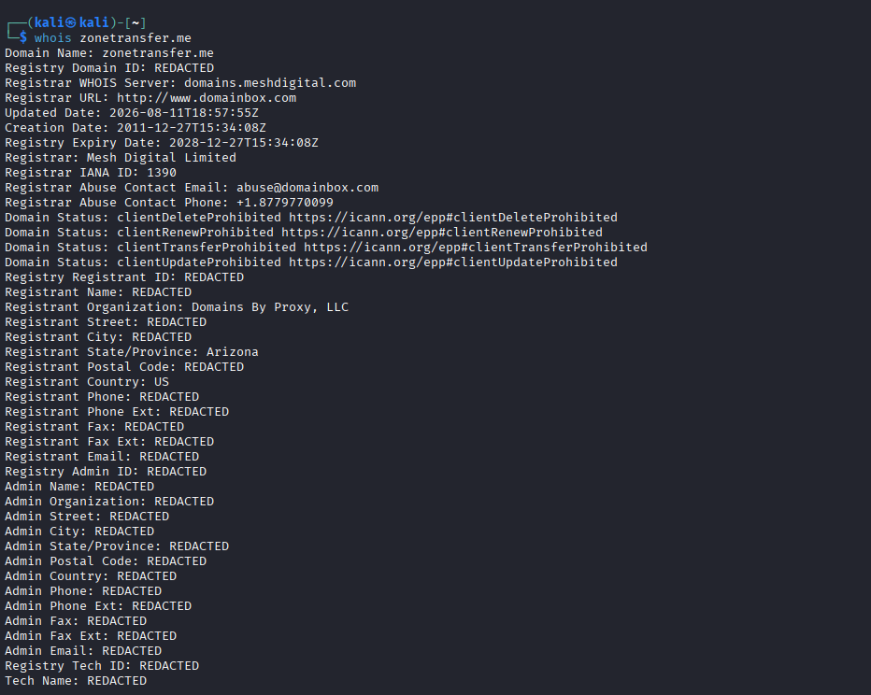
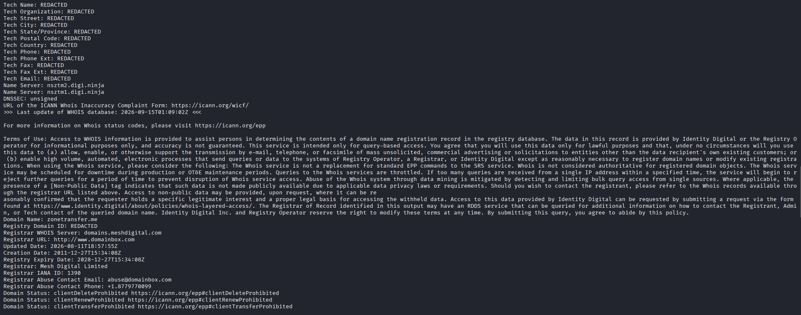

3. Technology Fingerprinting
Command:
- whatweb zonetransfer.me
Record Findings:
• Web Server: _________Apache___________
• Framework/CMS: _____PHP (custom site; no CMS detected)_______
Screenshot:
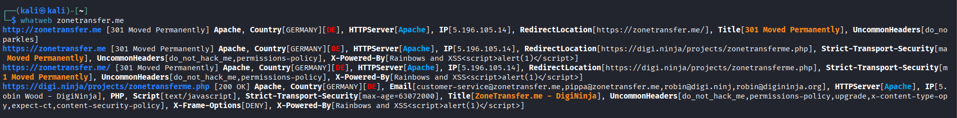

4. DNSDumpster Mapping
Go to: https://dnsdumpster.com
Record:
• Subdomains Identified: _____www.zonetransfer.me____
• MX Servers: ________aspmx.l.google.com, aspmx3.googlemail.com, aspmx4.googlemail.com, aspmx5.googlemail.com, alt2.aspmx.l.google.com, alt1.aspmx.l.google.com, aspmx2.googlemail.com_________
• Network Info: ____Web server hosted by OVH SAS, ASN 16276, IP range 5.196.0.0/16, France; DNS infrastructure also uses RouteLabel V.O.F., ASN 198203, Netherlands._____
Screenshot:
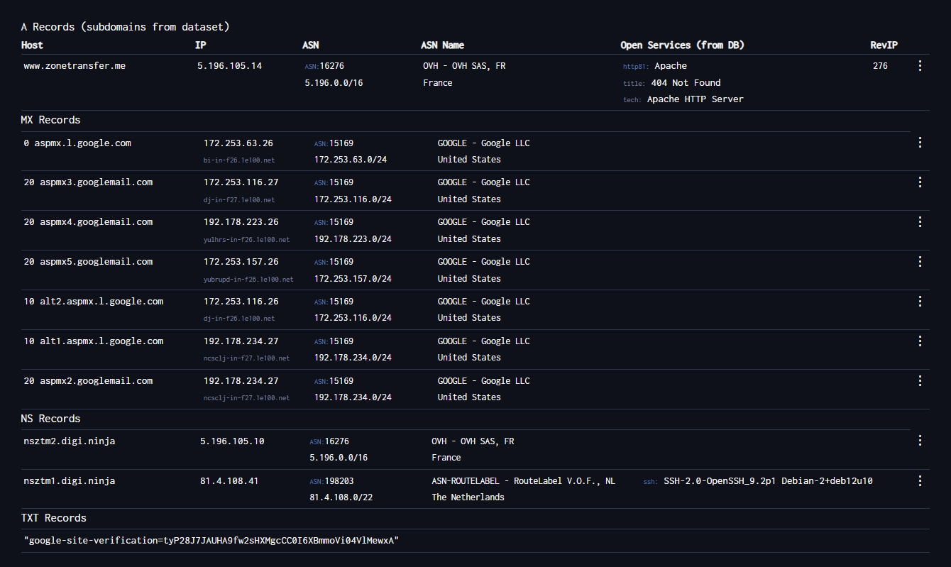
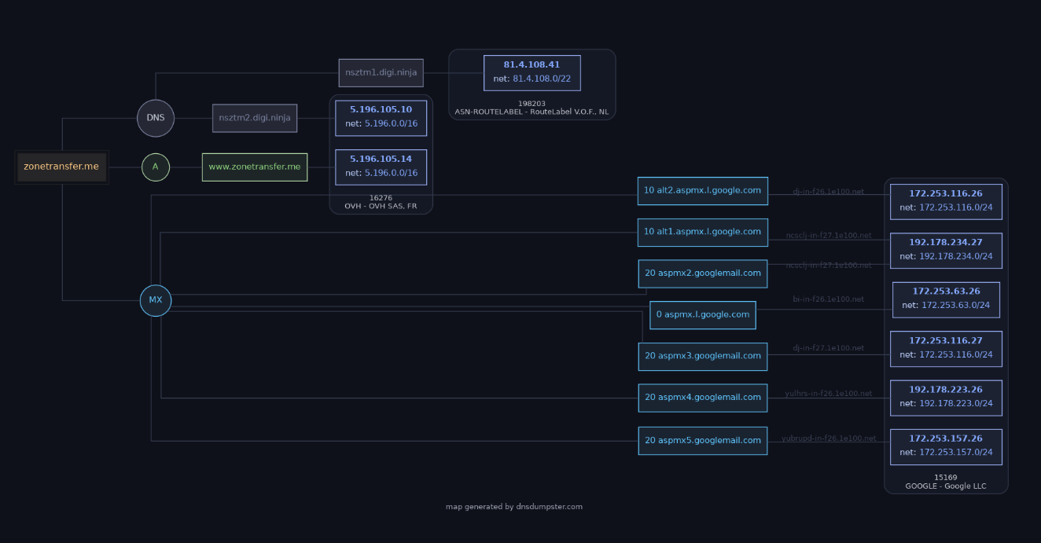

5. Passive Subdomain Enumeration

Commands:
- sublist3r -d apu.edu.my
- Google Dork:
site:*.apu.edu.my -site:apu.edu.my
Record all subdomains here:
- www.apu.edu.my
- admissions.apu.edu.my
- apspace.apu.edu.my
- dlh.apu.edu.my
- fyppgbank.apu.edu.my
- hr.apu.edu.my
- jati.apu.edu.my
- onlinepayment.apu.edu.my
- publicwebsite-media.apu.edu.my
- rmc.apu.edu.my

SESSION 2 — Active Recon

1. DNS Zone Transfer Attempt

Command:
- dnsrecon -d zonetransfer.me -t axfr
Record:
• Zone Transfer Success? Yes
• Records Obtained:
SOA: nsztm1.digi.ninja (81.4.108.41)

NS:
nsztm1.digi.ninja (81.4.108.41)
nsztm2.digi.ninja (5.196.105.10)
intns1.zonetransfer.me (81.4.108.41)
intns2.zonetransfer.me (5.196.105.10)

A:
zonetransfer.me -> 5.196.105.14
www.zonetransfer.me -> 5.196.105.14
asfdbbox.zonetransfer.me -> 127.0.0.1
home.zonetransfer.me -> 127.0.0.1
canberra-office.zonetransfer.me -> 202.14.81.230
dc-office.zonetransfer.me -> 143.228.181.132
email.zonetransfer.me -> 74.125.206.26
intns1.zonetransfer.me -> 81.4.108.41
intns2.zonetransfer.me -> 5.196.105.10
office.zonetransfer.me -> 4.23.39.254
owa.zonetransfer.me -> 207.46.197.32
vpn.zonetransfer.me -> 174.36.59.154
alltcpportsopen.firewall.test.zonetransfer.me -> 127.0.0.1

AAAA:
deadbeef.zonetransfer.me -> dead:beaf::
ipv6actnow.org.zonetransfer.me -> 2001:67c:2e8:11::c100:1332

CNAME:
staging.zonetransfer.me -> www.sydneyoperahouse.com

MX:
ASPMX.L.GOOGLE.COM
ALT1.ASPMX.L.GOOGLE.COM
ALT2.ASPMX.L.GOOGLE.COM
ASPMX2.GOOGLEMAIL.COM
ASPMX3.GOOGLEMAIL.COM
ASPMX4.GOOGLEMAIL.COM
ASPMX5.GOOGLEMAIL.COM

TXT:
google-site-verification=tyP28J7JAUHA9fw2sHXMgcCC0I6XBmmoVi04VlMewxA
6Oa05hbUJ9xSsvYy7pApQvwCUSSGgxvrbdizjePEsZI
; ls
AbCdEfG
Hi to Josh and all his class
' or 1=1 --
() { :]}; echo ShellShocked
'><script>alert('Boo')</script>

SRV:
_sip._tcp.zonetransfer.me -> www:5060

HINFO:
Casio fx-700G, Windows XP

LOC:
53°20'56.558"N, 1°38'33.526"W

NAPTR:
email.zonetransfer.me
sip:customer-service@zonetransfer.me

PTR:

5.196.105.14 -> www.zonetransfer.me

2. Subdomain Brute Force

Command:
- fierce -domain zonetransfer.me
Record discovered subdomains:
- _acme-challenge.zonetransfer.me
- _sip._tcp.zonetransfer.me
- asfdbauthdns.zonetransfer.me
- asfdbbox.zonetransfer.me
- asfdbvolume.zonetransfer.me
- canberra-office.zonetransfer.me
- cmdexec.zonetransfer.me
- contact.zonetransfer.me
- dc-office.zonetransfer.me
- deadbeef.zonetransfer.me
- dr.zonetransfer.me
- DZC.zonetransfer.me
- email.zonetransfer.me
- Hello.zonetransfer.me
- home.zonetransfer.me
- Info.zonetransfer.me
- internal.zonetransfer.me
- intns1.zonetransfer.me
- intns2.zonetransfer.me
- office.zonetransfer.me
- owa.zonetransfer.me
- robinwood.zonetransfer.me
- rp.zonetransfer.me
- sip.zonetransfer.me
- sqli.zonetransfer.me
- sshock.zonetransfer.me
- staging.zonetransfer.me
- testing.zonetransfer.me
- vpn.zonetransfer.me
- www.zonetransfer.me
- xss.zonetransfer.me

3. Port Scanning

Commands:
- nmap -sS -T3 <IP>
- nmap -sV -p 80,443 <IP>
Findings:
• Open Ports: 80, 443, 8080
• Service Versions: Apache httpd (Sparkles), Apache httpd (Rainbows and XSS<script>alert(1)</script>)
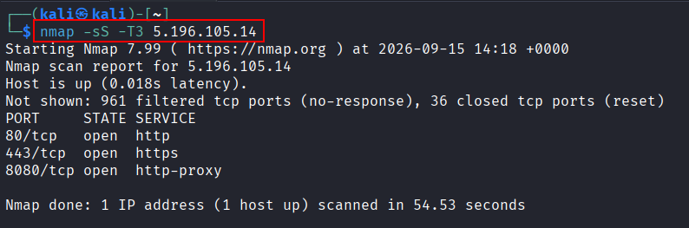
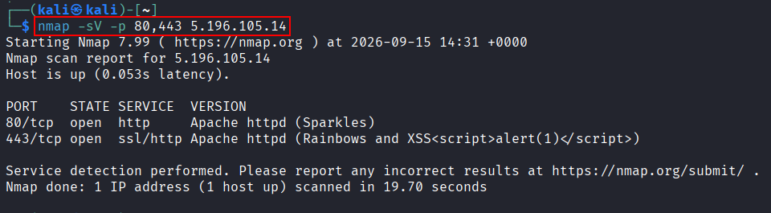

4. Vulnerability Recon

Command:
- nikto -h https://zonetransfer.me
Record findings:
Nikto identified Apache and several custom HTTP headers:
- X-Powered-By: Rainbows and XSS<script>alert(1)</script>
- do_not_hack_me: Please
- x-xss header on the DigiNinja redirect page
These appear to be intentional banner values or lab markers. No confirmed vulnerability was established. The scan terminated after reaching the 20-error limit because of connection timeouts.
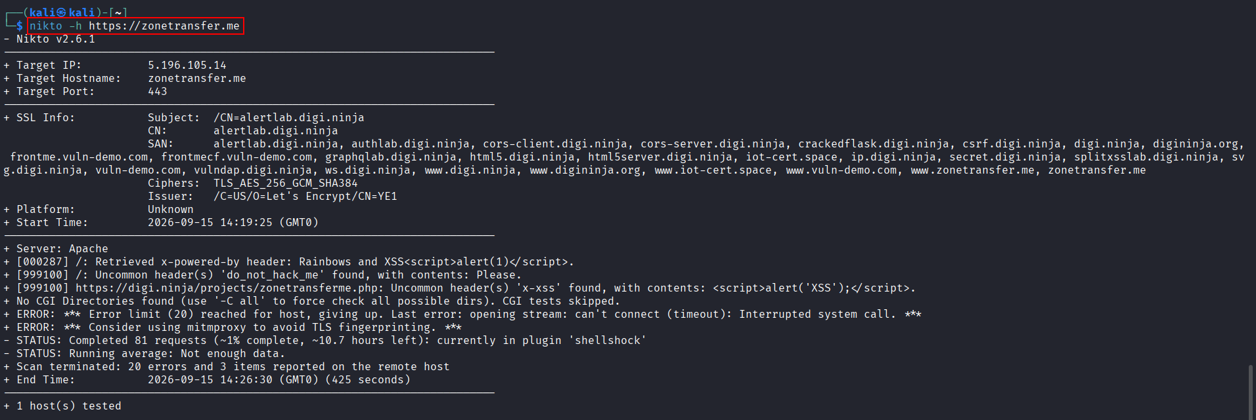

5. Automated Recon – Sn1per (Optional)s

Command:
- sudo sniper -t zonetransfer.me (Active recon)
- sudo sniper -t zonetransfer.me -m stealth -o -re (Passive recon)
Record interesting findings:
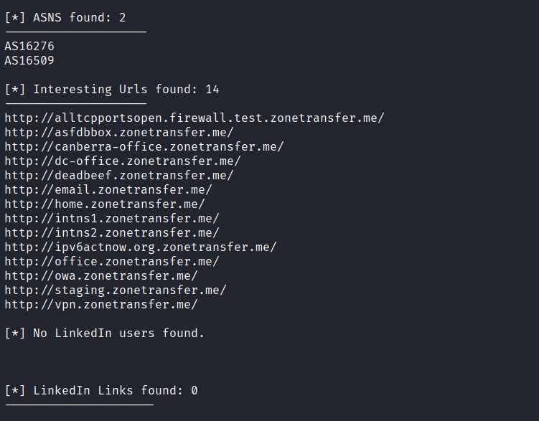
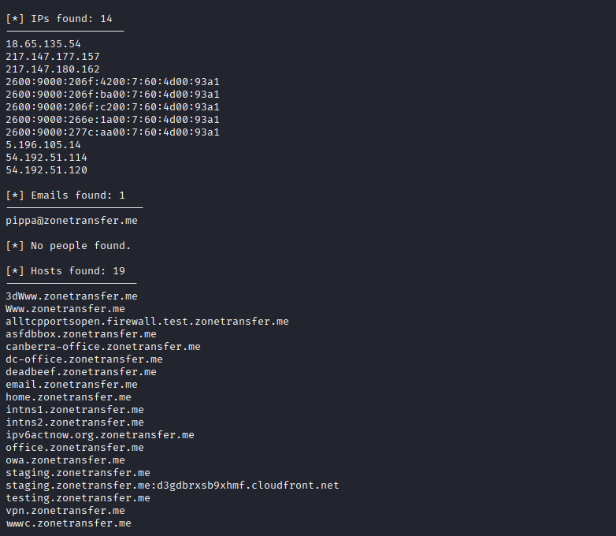

Summary Findings

1. Passive Recon Summary
The reconnaissance identified the following information:
Finding | Details
Target domain | zonetransfer.me
IP address | 5.196.105.14
Name servers | nsztm1.digi.ninja, nsztm2.digi.ninja
Mail provider | Google Mail servers
Registrar | Mesh Digital Limited
Registrant organization | Domains By Proxy, LLC
Hosting provider | DigiNinja
Web server | Apache
Technology | PHP-based custom website; no CMS detected
Network | OVH SAS, ASN 16276, France
DNS infrastructure | RouteLabel V.O.F., ASN 198203, Netherlands
Discovered subdomain | www.zonetransfer.me

Passive enumeration of apu.edu.my identified these subdomains:
- www.apu.edu.my
- admissions.apu.edu.my
- apspace.apu.edu.my
- dlh.apu.edu.my
- fyppgbank.apu.edu.my
- hr.apu.edu.my
- jati.apu.edu.my
- onlinepayment.apu.edu.my
- publicwebsite-media.apu.edu.my
- rmc.apu.edu.my

2. Active Recon Summary
- DNS zone transfer: Successful against the authoritative name servers.
- Name servers: nsztm1.digi.ninja, nsztm2.digi.ninja
- Internal name servers: intns1.zonetransfer.me, intns2.zonetransfer.me
- IP addresses discovered: 5.196.105.14, 202.14.81.230, 143.228.181.132, 4.23.39.254, 207.46.197.32, 174.36.59.154, and other mapped addresses.
- Open ports: 80, 443, and 8080
- Web service: Apache HTTP Server
- Port 80 fingerprint: Apache httpd (Sparkles)
- Port 443 fingerprint: Apache httpd (Rainbows and XSS<script>alert(1)</script>)
- CNAME record: staging.zonetransfer.me points to www.sydneyoperahouse.com
- Other records obtained: MX, TXT, SRV, HINFO, LOC, NAPTR, PTR, AFSDB, CERT, and DNSKEY records.
- Nikto findings: Apache and unusual custom headers were identified. The banner values appear to be intentional lab markers. The scan encountered timeouts and did not confirm an exploitable vulnerability.
- Sn1per findings: Port 8080 was confirmed open. Sn1per produced false-positive vulnerability results from external URLs and encountered missing tools and connection timeouts. No confirmed exploitable vulnerability was identified.

3. Subdomain List (all tools)
- _acme-challenge.zonetransfer.me
- _sip._tcp.zonetransfer.me
- asfdbauthdns.zonetransfer.me
- asfdbbox.zonetransfer.me
- asfdbvolume.zonetransfer.me
- canberra-office.zonetransfer.me
- cmdexec.zonetransfer.me
- contact.zonetransfer.me
- dc-office.zonetransfer.me
- deadbeef.zonetransfer.me
- dr.zonetransfer.me
- DZC.zonetransfer.me
- email.zonetransfer.me
- Hello.zonetransfer.me
- home.zonetransfer.me
- Info.zonetransfer.me
- internal.zonetransfer.me
- intns1.zonetransfer.me
- intns2.zonetransfer.me
- office.zonetransfer.me
- owa.zonetransfer.me
- robinwood.zonetransfer.me
- rp.zonetransfer.me
- sip.zonetransfer.me
- sqli.zonetransfer.me
- sshock.zonetransfer.me
- staging.zonetransfer.me
- testing.zonetransfer.me
- vpn.zonetransfer.me
- www.zonetransfer.me
- ipv6actnow.org.zonetransfer.me
- alltcpportsopen.firewall.test.zonetransfer.me

4. Screenshots for each step

4.1 DNS & Domain Enumeration

4.2 WHOIS Lookups

4.3 Technology Fingerprinting

4.4 DNSDumpster Mapping

4.6 DNS Zone Transfer
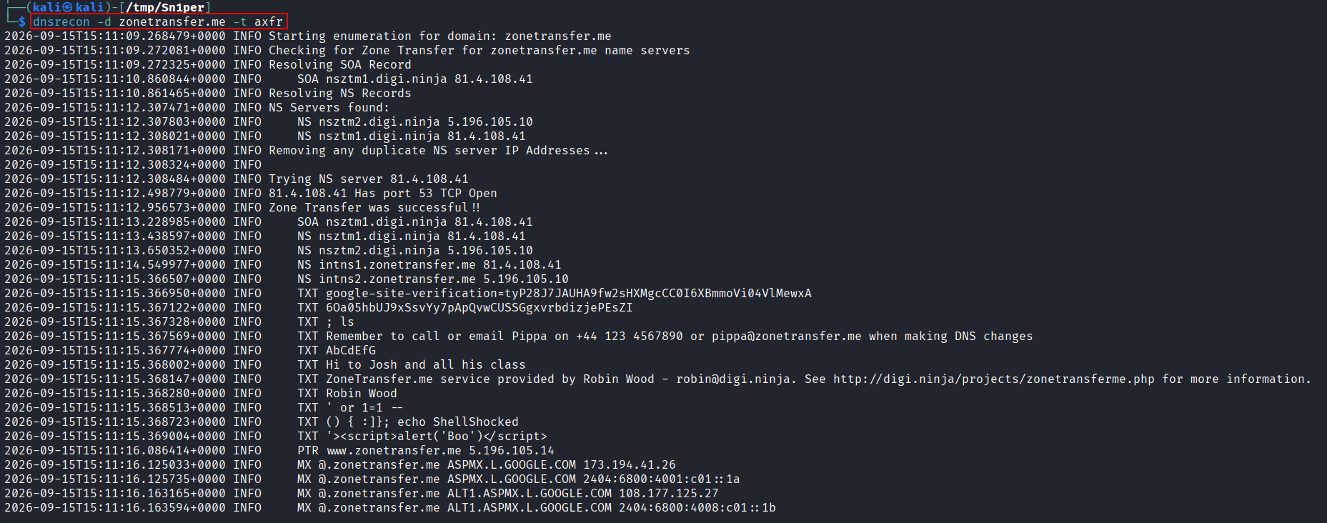

4.7 Port Scanning

4.8 Vulnerability Recon

5. Final written report
The assessment identified the attack surface associated with zonetransfer.me through passive and active reconnaissance techniques.
Passive enumeration identified the domain IP address as 5.196.105.14. The authoritative name servers are nsztm1.digi.ninja and nsztm2.digi.ninja, while email services are hosted by Google Mail servers. WHOIS information identified Mesh Digital Limited as the registrar, Domains By Proxy, LLC as the registrant organization, and DigiNinja as the hosting provider. Technology fingerprinting identified Apache as the web server and PHP as the likely web technology, with no CMS detected.
DNSDumpster identified www.zonetransfer.me and associated the web infrastructure with OVH SAS, ASN 16276, in France. The DNS infrastructure also included RouteLabel V.O.F., ASN 198203, in the Netherlands. Passive enumeration of apu.edu.my identified several university-related subdomains, including admissions.apu.edu.my, apspace.apu.edu.my, dlh.apu.edu.my, and onlinepayment.apu.edu.my.
Active reconnaissance confirmed that a DNS zone transfer was permitted. The transfer exposed authoritative DNS records, internal name servers, multiple hostnames, IP addresses, mail servers, TXT records, service records, and other DNS metadata. This represents a significant information disclosure issue because DNS zone transfers should normally be restricted to authorized secondary name servers.
Port scanning identified TCP ports 80, 443, and 8080 as open. Service detection identified Apache HTTP Server on ports 80 and 443. Several unusual server banner values were observed, including Sparkles and Rainbows and XSS<script>alert(1)</script>. Additional records revealed references to internal systems, VPN, office hosts, staging infrastructure, email services, and test-style hostnames.
Overall, the most significant finding is the successful DNS zone transfer, which exposed a large amount of domain information. Recommended remediation includes restricting AXFR requests to authorized name servers, reviewing exposed DNS records, removing unnecessary test and internal entries, limiting service banners, and reviewing the security of all discovered web services and subdomains.

